PayDollar/PesoPay/SiamPay Setup Guide – Magento Payment Module Setup Guide

This module has been tested on these magento CE versions: 1.8, 1.9

Outline
1.) Install and setup the PayDollar module
2.) Configure the currency
3.) Setup Datafeed (Callback) URL on your PayDollar merchant account
4.) Feature: Query Payment Status - Description

1.) Install the PayDollar module

1.1. Upload the PayDollar plugin following the correct folder structure.
1.2. After installation, go to the admin side of the store and log-in, then go to System -> Configurations -> Advanced > Advanced
1.3. Ensure that the module 'Asiapay_Pdcptb' is enabled.
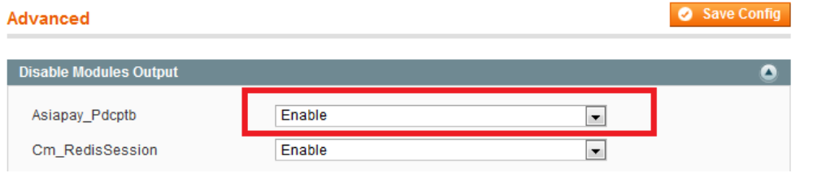
1.4. Then go to "Payment Methods" then expand the “AsiaPay's PayDollar - Client Post Through Browser Module” then configure the values accordingly then save changes.
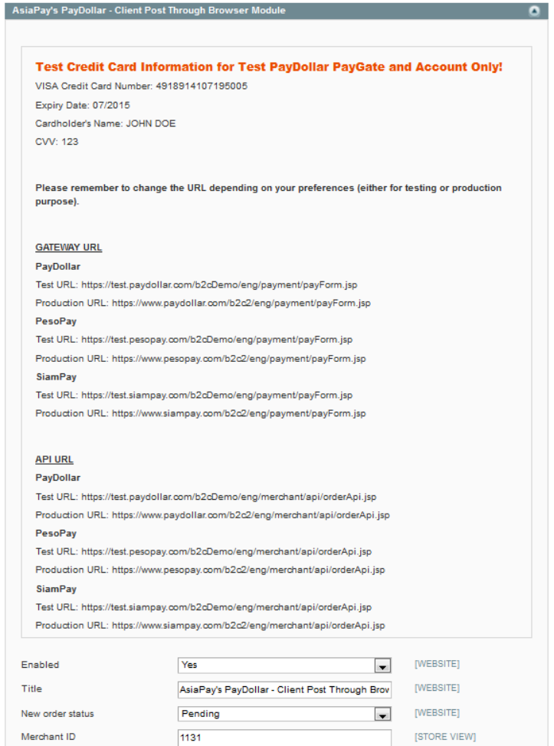

Here are the field description:
1. Enabled: turns the module on or off (also affects visibility of the module on the front end)
2. Title: module’s name (for display purposes only); Default: AsiaPay's PayDollar – Client Post Through Browser
3. New order status: refers to the status of the order upon checkout (Pending – default statuses for orders / Processing – refers to a paid approved transaction by the gateway; as much as possible, do not use this method as it may cause confusion for when the order transaction has been paid or not); Default: Pending – absolutely NOT advised to change to Processing
4. Merchant ID: merchant ID issued to you by AsiaPay. Default: (none)
5. Gateway URL: URL to which the data from the merchant website is being passed to (use the test server indicated if the merchant is performing trials; use the live production server URL if the live account has been formally issued by AsiaPay);
PayDollar
Test URL: https://test.paydollar.com/b2cDemo/eng/payment/payForm.jsp
Production URL: https://www.paydollar.com/b2c2/eng/payment/payForm.jsp
PesoPay
Test URL: https://test.pesopay.com/b2cDemo/eng/payment/payForm.jsp
Production URL: https://www.pesopay.com/b2c2/eng/payment/payForm.jsp
SiamPay
Test URL: https://test.siampay.com/b2cDemo/eng/payment/payForm.jsp
Production URL: https://www.siampay.com/b2c2/eng/payment/payForm.jsp

6. Payment from Applicable Countries: Affects usage and visibility of module for different countries (All countries, specific countries); Default: (none)
7. Payment from Specific Countries: becomes selectable once Payment from Specific Countries is activated. Selects countries to which module may be shown.; Default: (none)
8. Minimum Order Total: Minimum amount for the total products bought; Default: blank
9. Maximum Order Total: Maximum amount for the total products bought; Default: blank
10. Sort Order: Order of the module on the front end; Default: 0
11. Prefix for Order Reference No.: String that may be added before the actually order no. to identify the transaction; note that the usage of a dash “-“ is prohibited because it is being used by the system as a separator between the prefix and the actual order no. from Magento’s auto-incrementing order stub; Default: (none)
12. Payment Type: N for Normal/Sale, H for Hold/Authorize. Please check with PayDollar/PesoPay/SiamPay
13. Gateway Language: The language that will be used by the gateway, type: C for Traditional Chinese, X for Simplified Chinese, E for English, K for Korean, J for Japanese, T for Thai, G for German, S for Spanish, F for French, R for Russian, V for Vietnamese; Default: E
14. Secure Hash Secret: Optional, if secureHash function is enabled on your merchant account, set the secret word here. Default: blank
15. MemberPay: Optional, if MemberPay function is enabled on your merchant account, set to T. Otherwise, set to F
16. API URL: The API URL of PayDollar/PesoPay/SiamPay
PayDollar
Test URL: https://test.paydollar.com/b2cDemo/eng/merchant/api/orderApi.jsp
Production URL: https://www.paydollar.com/b2c2/eng/merchant/api/orderApi.jsp
PesoPay
Test URL: https://test.pesopay.com/b2cDemo/eng/merchant/api/orderApi.jsp
Production URL: https://www.pesopay.com/b2c2/eng/merchant/api/orderApi.jsp
SiamPay
Test URL: https://test.siampay.com/b2cDemo/eng/merchant/api/orderApi.jsp
Production URL: https://www.siampay.com/b2c2/eng/merchant/api/orderApi.jsp

17. API Username: Assigned by PayDollar/PesoPay/SiamPay to merchant
18. API Password: Assigned by PayDollar/PesoPay/SiamPay to merchant

2.) Configure the Currency

2.1. The Base currency and the Default display currency must be changed to HKD or USD whichever the merchant will use by default for the online transactions. The Allowed currency may be set to both HKD and USD as the highlighted currencies.
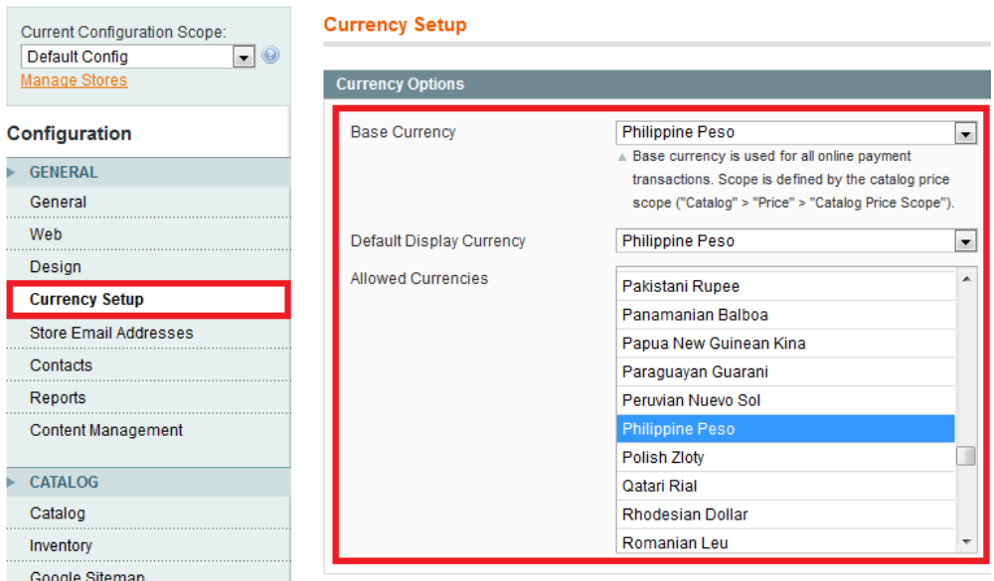

3. Setup Datafeed (Callback) URL on your PayDollar merchant account

3.1. Login to your PayDollar/PesoPay/SiamPay account.
PayDollar
Live: https://www.paydollar.com/b2c2/eng/merchant/index.jsp
Test: https://test.paydollar.com/b2cDemo/eng/merchant/index.jsp
PesoPay
Live: https://www.pesopay.com/b2c2/eng/merchant/index.jsp
Test: https://test.pesopay.com/b2cDemo/eng/merchant/index.jsp
SiamPay
Live: https://www.siampay.com/b2c2/eng/merchant/index.jsp
Test: https://test.siampay.com/b2cDemo/eng/merchant/index.jsp

3.2. After login, Go to left sidebar on Profile > Profile Settings > Payment Options.
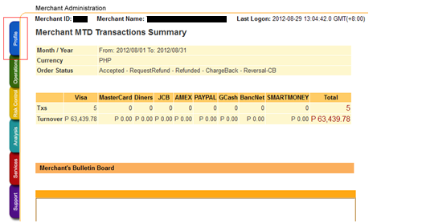

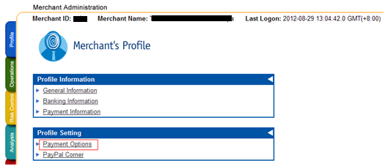
3.3. Click the “Enable” radio and set the datafeed URL on “Return Value Link” and click the “Update” button.
The datafeed URL should be like this: http://www.yourmagentosite.com/datafeed/datafeed.php
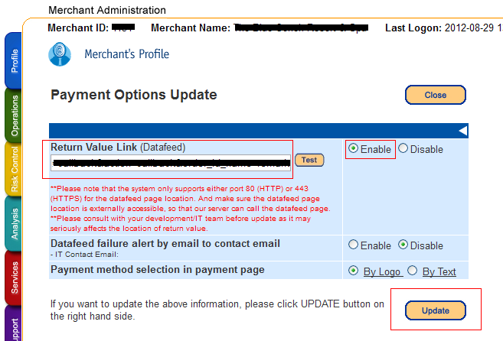

3.4. On the confirmation page, review your changes then click the “Confirm button”.
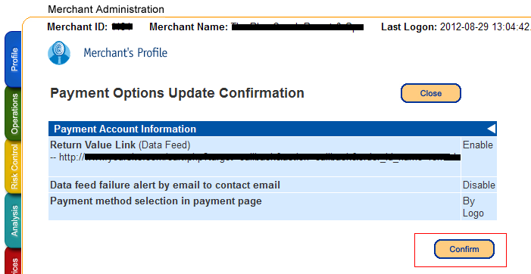

3.5. The datafeed URL has been set.
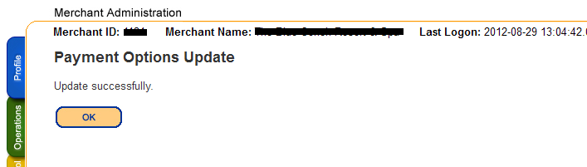

4. Feature: Query Payment Status - Description

4.1. There are certain scenarios where the order status is stuck in Pending status even if the datafeed is setup properly. This could be related to a scenario where the customer is redirected to the payment gateway for payment processing but the customer did not proceed with the payment and e.g. closed the browser, etc... When this happen, the order status on magento remains in Pending because it did not receive payment result from the payment gateway and PayDollar/PesoPay/SiamPay did not sent out payment result because there is no payment record made at the payment gateway. For this we have added an admin function for Querying the payment gateway to check if there are any payments made by adding a new button on the order view page.

4.2. To set this up, you will need to alter 1 core magento file. Find the /app/code/core/Mage/Adminhtml/Block/Sales/Order/View.php and add the following codes on the constructor. This code will add the new Button on the order view page and will only appear IF the order was made using PayDollar/PesoPay/SiamPay AND the order state is New (The Pending status).
====================== code to paste - start ======================
/* UPDATE INCLUDED BY PAYDOLLAR PAYMENT MODULE - START */
/**
* This button is added for PayDollar for QUERY API button for manual checking of payment result
*/
if($order->getPayment()->getMethodInstance()->getCode() == 'pdcptb'){
if($order->getData('state') == Mage_Sales_Model_Order::STATE_NEW){
$message = 'Query the Payment Gateway To Check If Any Payments Made?';
$url = Mage::helper('adminhtml')->getUrl('pdcptb/adminhtml_adminpdcptb/query/', array('order_id'=>$order->getId()));
$this->addButton('paydollar_query_api', array(
'label' => '[ --- PAYDOLLAR: QUERY PAYMENT STATUS --- ]',
'onclick' => "confirmSetLocation('{$message}', '{$url}')",
));
}
}
/* UPDATE INCLUDED BY PAYDOLLAR PAYMENT MODULE - END */
====================== code to paste - end ======================

4.3. Scenario 1: An order was made via PayDollar/PesoPay/SiamPay and the order state is New (status is Pending) But a transaction was actually made and is in Accepted/Authorize status on the payment gateway. This could be due to several issues like e.g. datafeed URL not yet set, datafeed URL is set but have have SSL errors, etc..
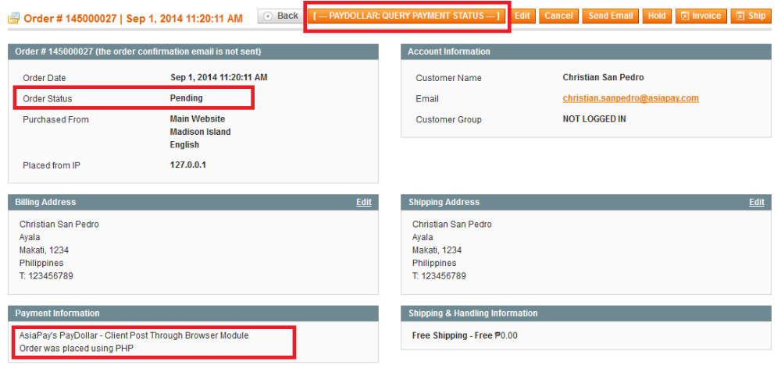
After clicking the “[ --- PAYDOLLAR: QUERY PAYMENT STATUS --- ]”, the page below is displayed
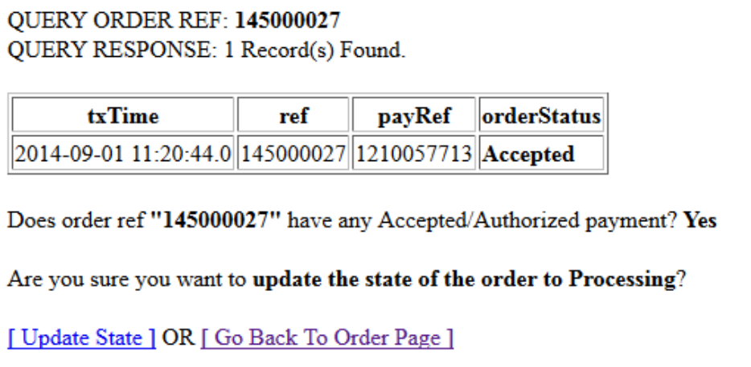

The page query the payment gateway to see if any payments made and the merchant can choose to click “[ Update State ]” to Update the state to Processing OR Go Back to the Order Page.

4.4. Scenario 2: An order was made via PayDollar/PesoPay/SiamPay and the order state is New (status is Pending) But a transaction was actually made and is in Rejected status on the payment gateway. This could be due to several issues like e.g. datafeed URL not yet set, datafeed URL is set but have have SSL errors, etc..
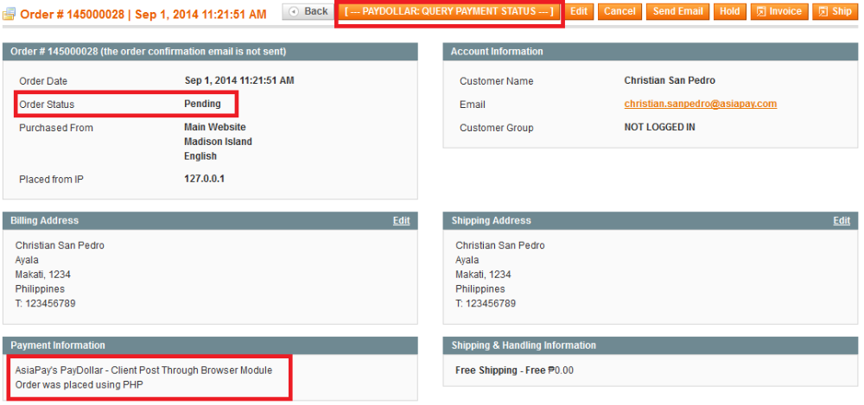
After clicking the “[ --- PAYDOLLAR: QUERY PAYMENT STATUS --- ]”, the page below is displayed
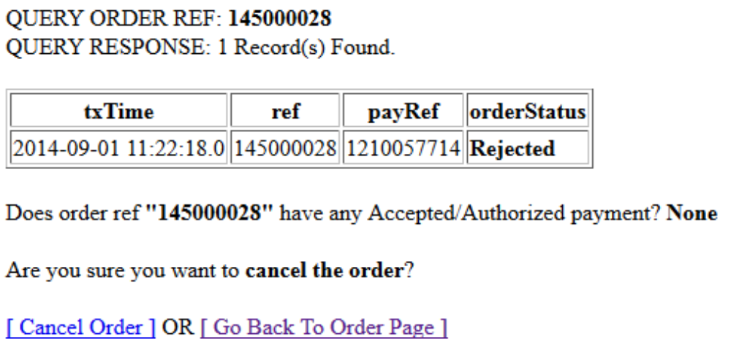
The page query the payment gateway to see if any payments made and the merchant can choose to click “[ Cancel Order ]” to cancel the order OR Go Back to the Order Page.

4.5. Scenario 3: An order was made via PayDollar/PesoPay/SiamPay and the order state is New (status is Pending) But there is no transaction found on the payment gateway. This could be due to several issues like e.g. after redirect from magento to the payment gateway, the customer did not proceed with the order and just closed the browser.
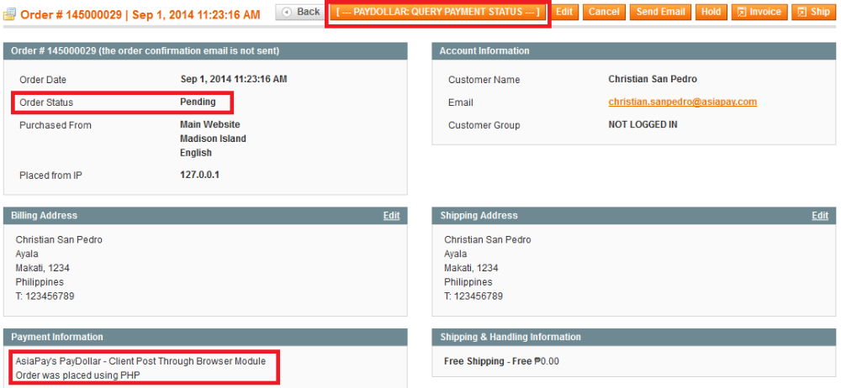
After clicking the “[ --- PAYDOLLAR: QUERY PAYMENT STATUS --- ]”, the page below is displayed
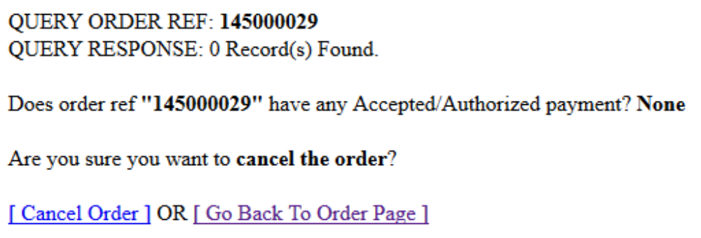
The page query the payment gateway to see if any payments made and the merchant can choose to click “[ Cancel Order ]” to cancel the order OR Go Back to the Order Page.

The End

